1. Initial validator errors

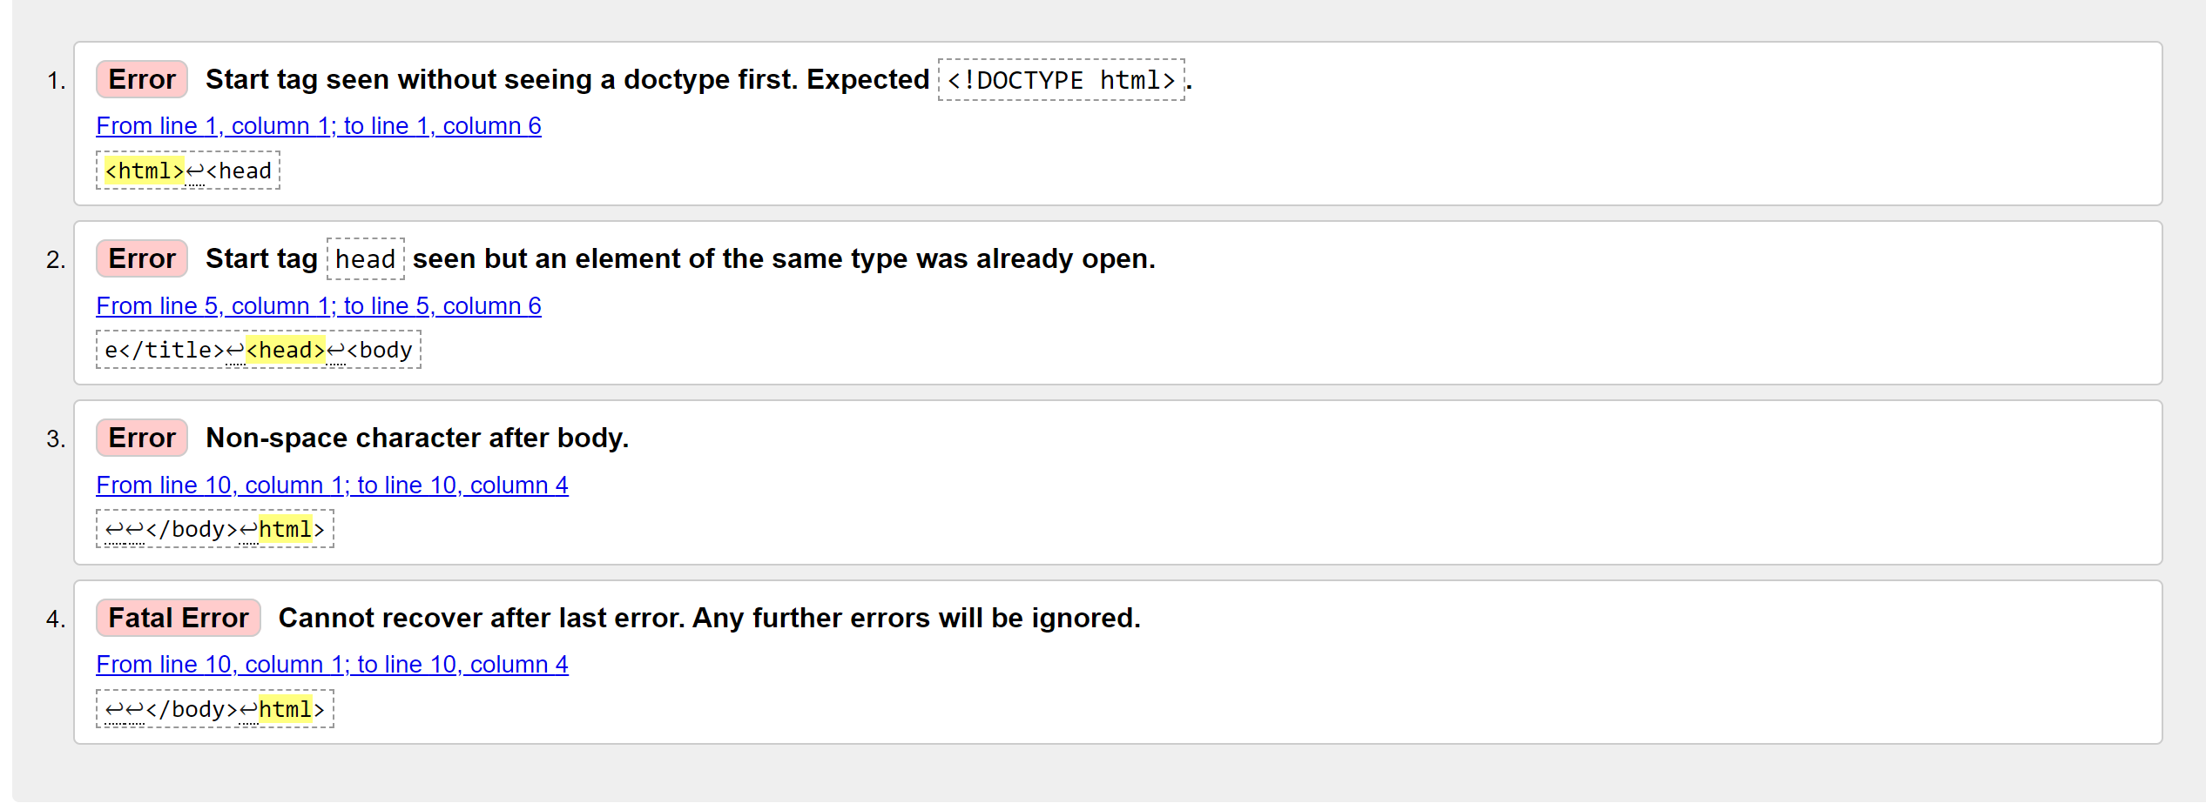

1. Errors cleared (part 1)

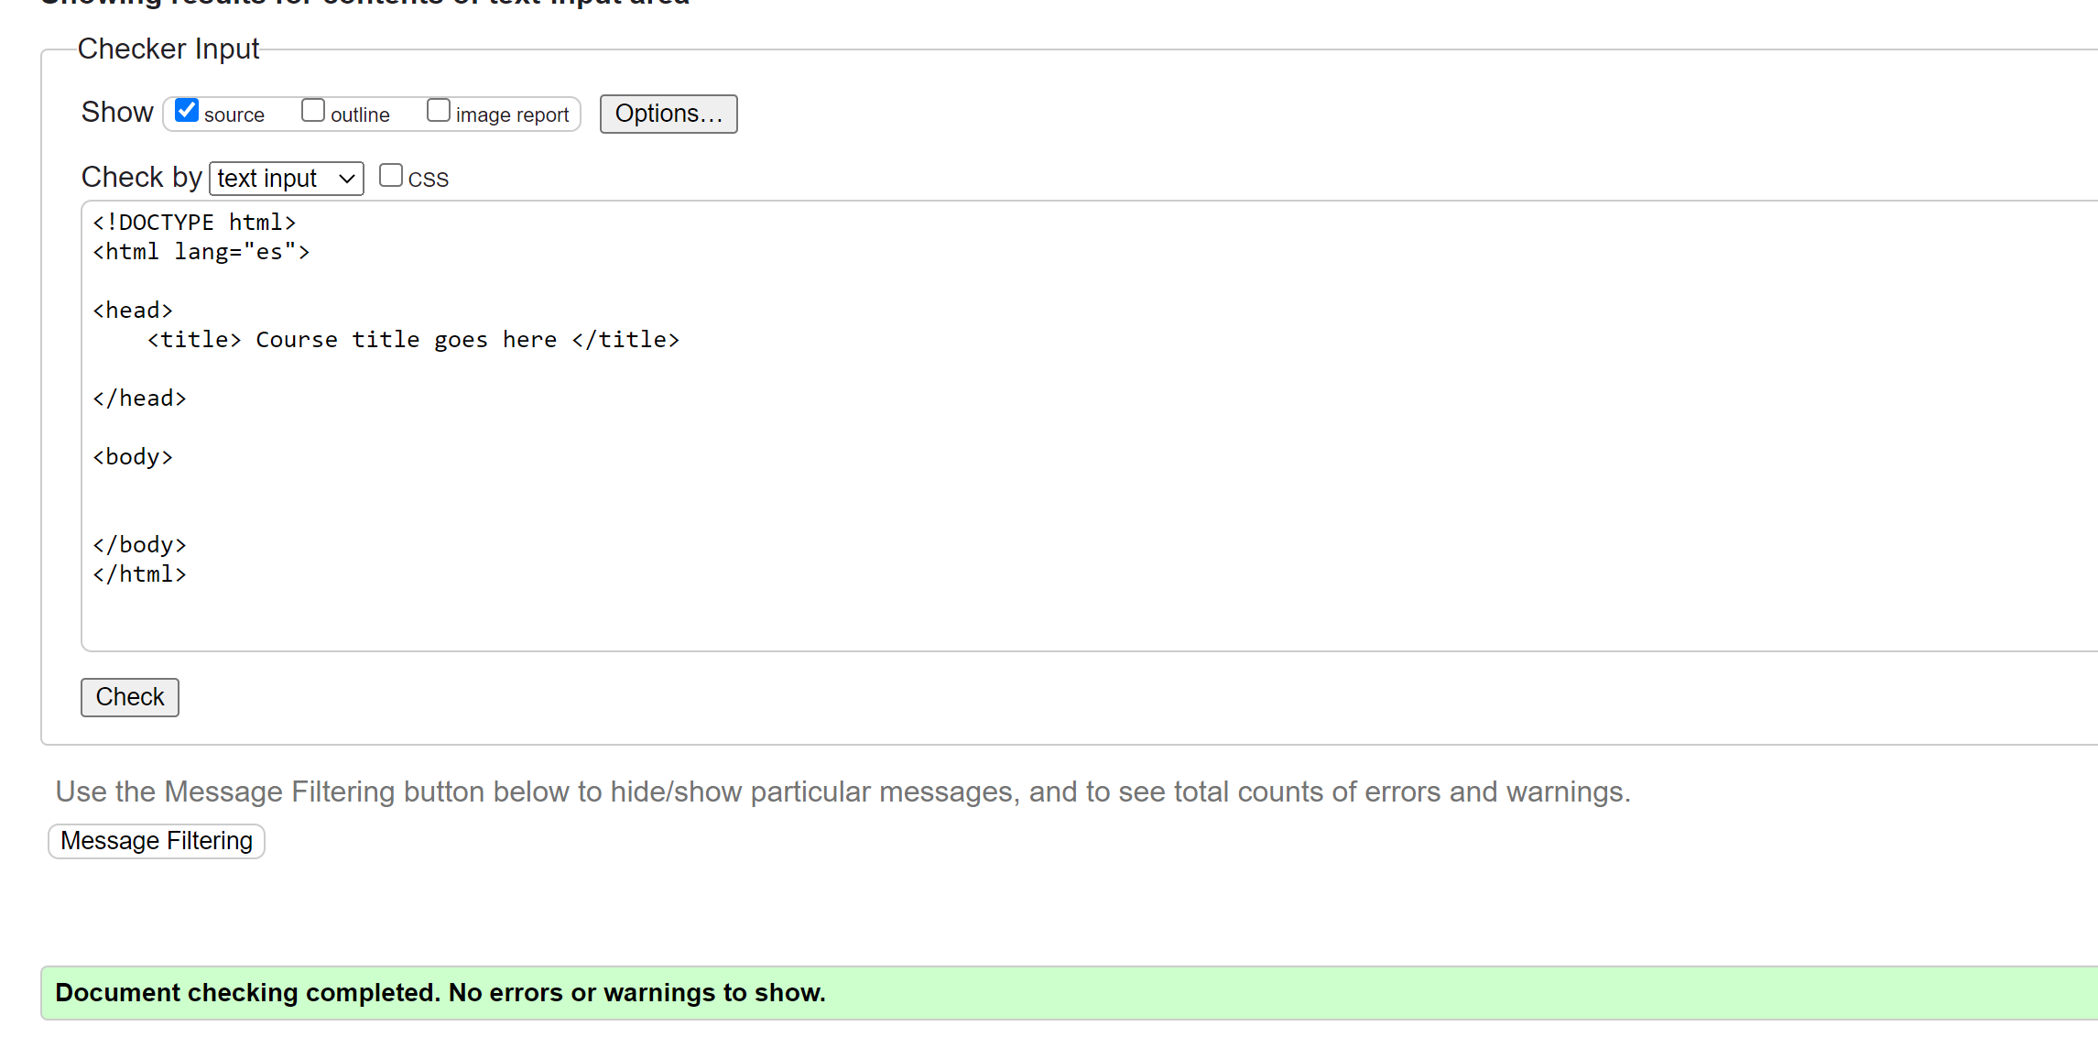

1. No errors on validator, code ready for webpage

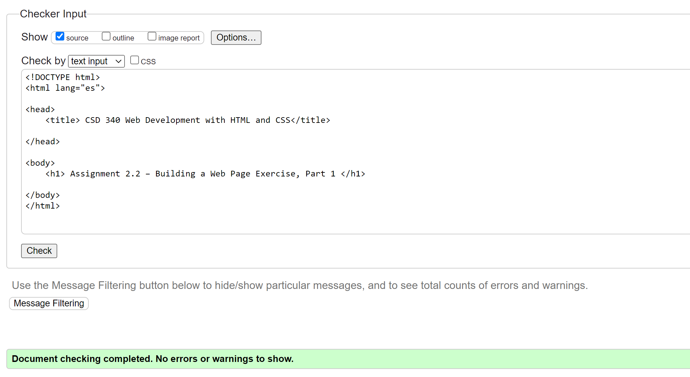

1. Webpage on Firefox

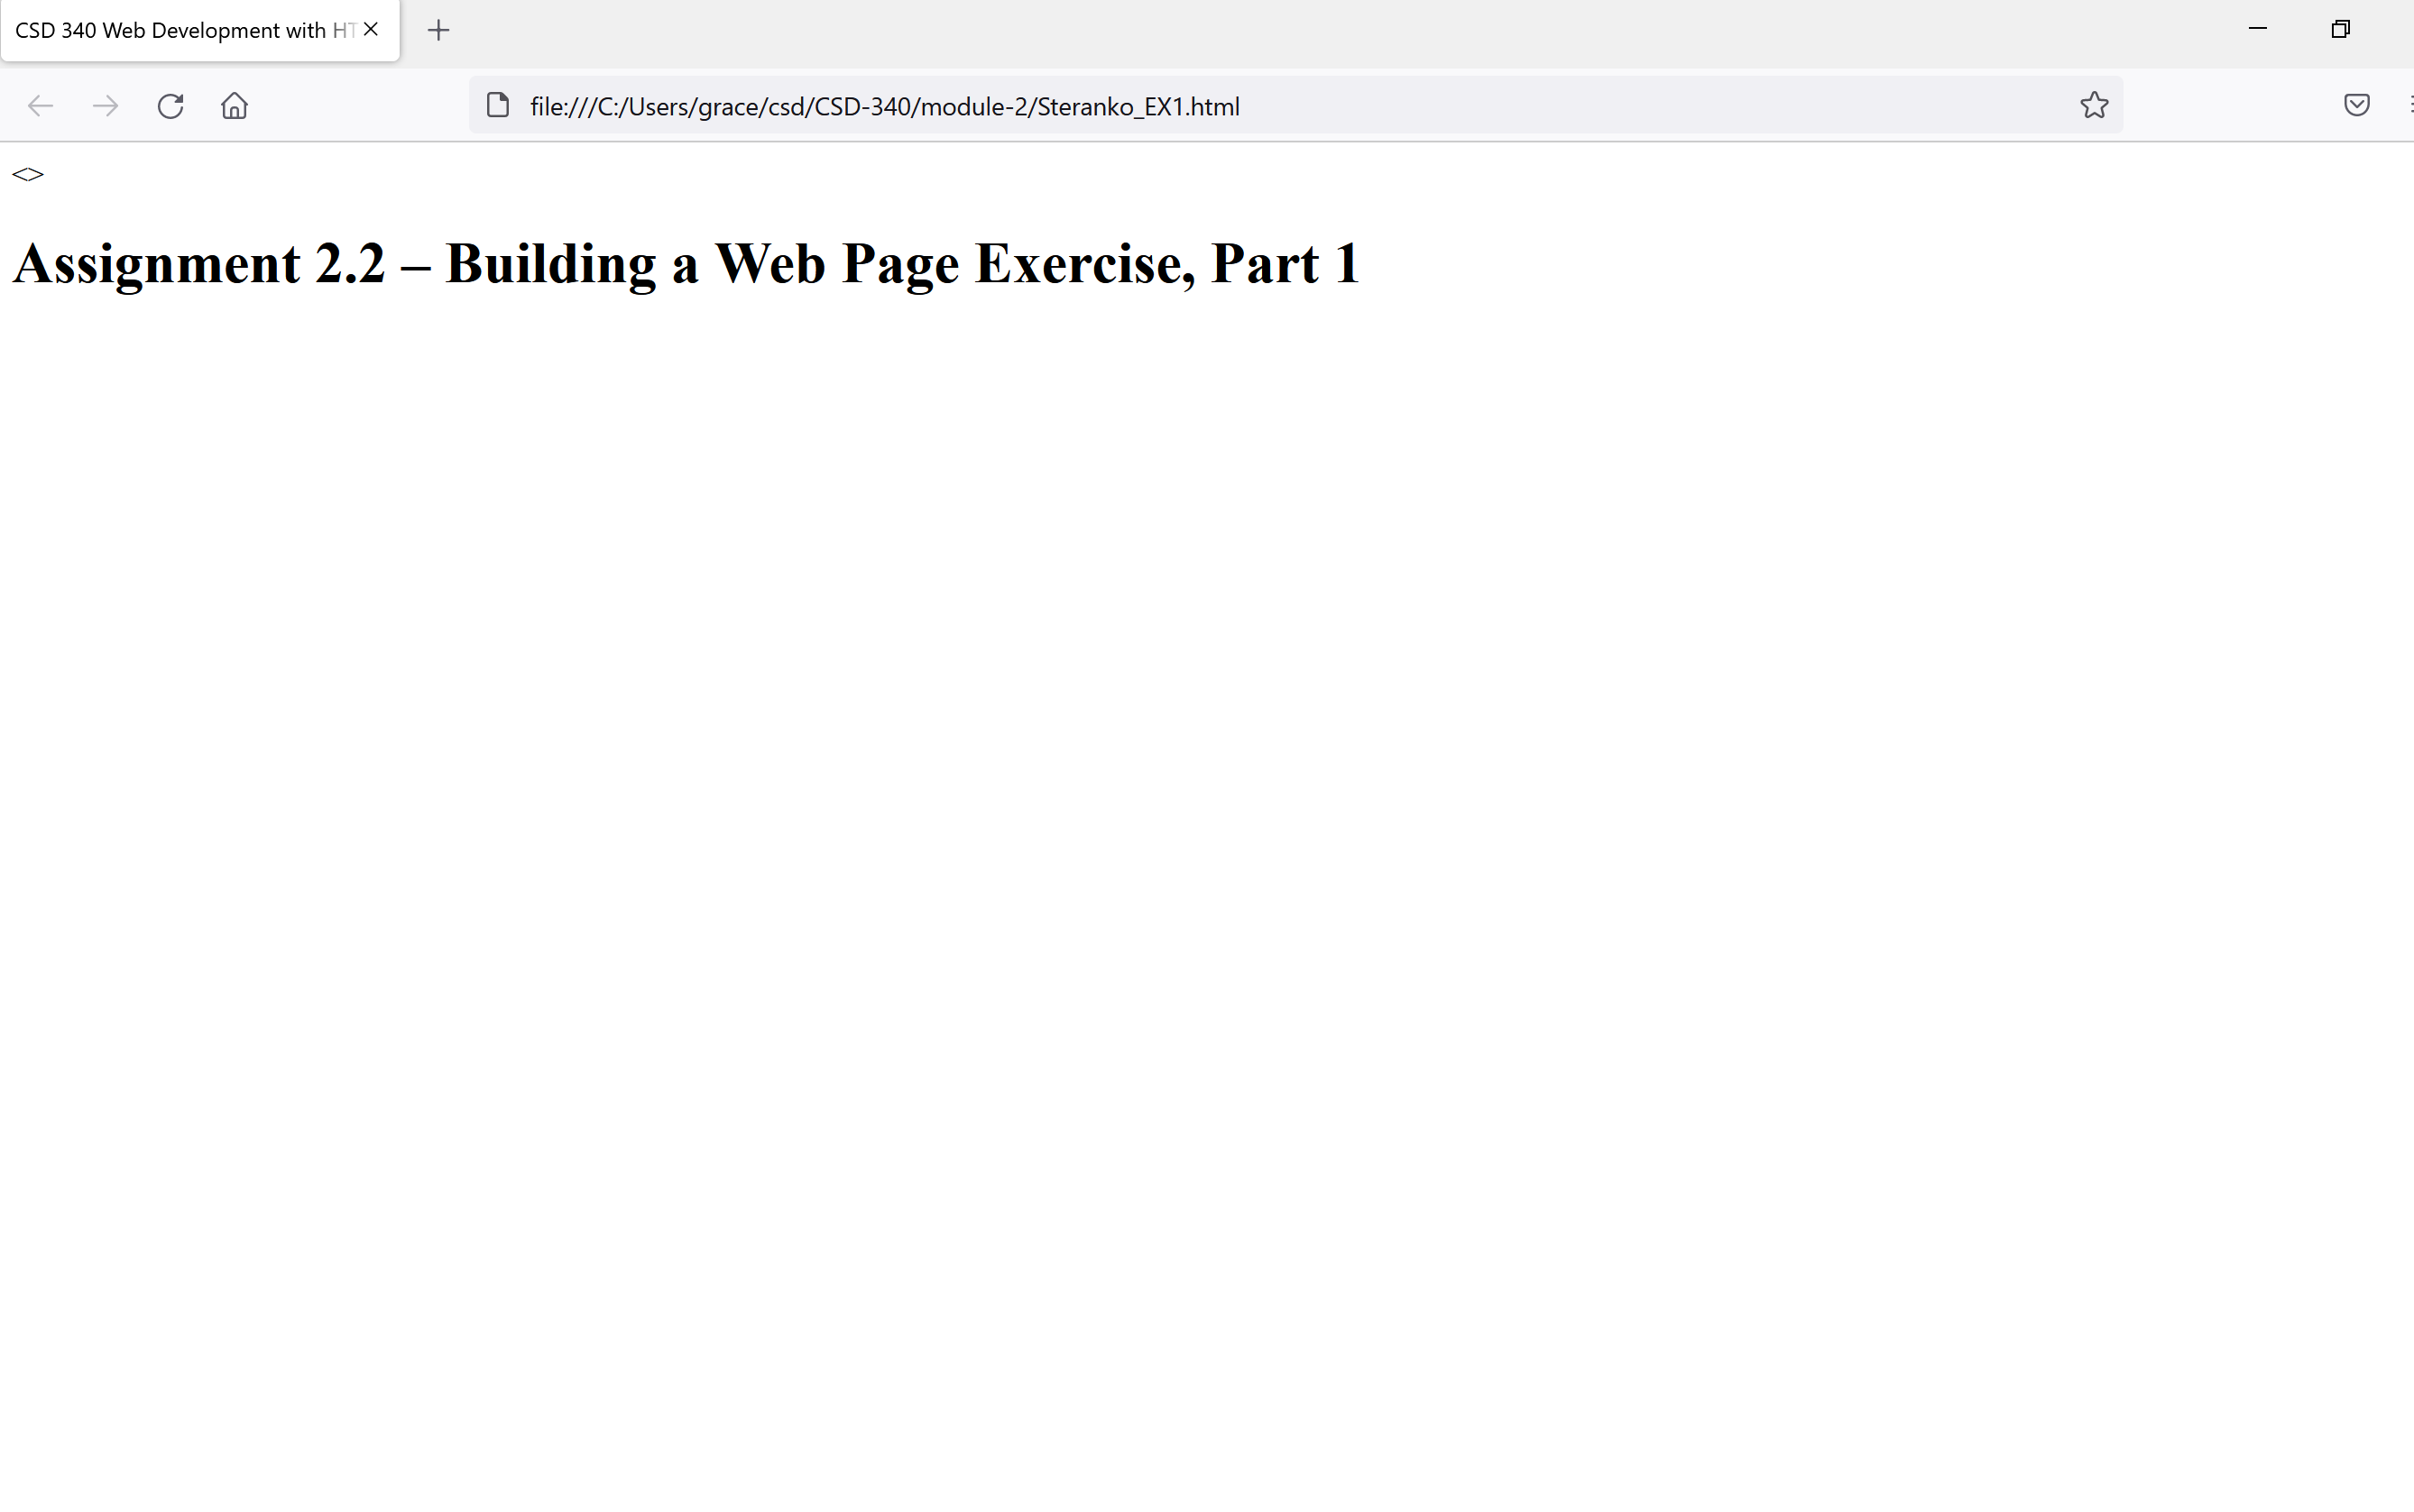

1. GItHub Link: <https://github.com/GRACESTER/csd-340/tree/module-2>